Computer Arithmetic
Arithmetic instructions in digital computers manipulate data to produce results necessary for the solution of computational problems. These instructions perform arithmetic calculations and are responsible for the bulk of activity involved in processing data in a computer. The four basic arithmetic operations are addition, subtraction, multiplication and division. From these four basic operations, it is possible to formulate other arithmetic functions and solve scientific problems by means of numerical analysis methods. An arithmetic processor is the part of a processor unit that executes arithmetic operations. An arithmetic instruction may specify binary or decimal data, and in each case the data may be in fixed-point or floating-point form. Fixed- point numbers may represent integers or fractions. Negative numbers may be in signed- magnitude or signed-complement representation. The arithmetic processor is very simple if only a binary fixed-point odd instruction is included. It would be more complicated if it includes all four arithmetic operations for binary and decimal data in fixed-point and floating- point representation.

Addition and Subtraction
There are three ways of representing negative fixed-point binary numbers: signed-magnitude, signed-l's complement, or signed-2's complement. Most computers use the signed-2's complement representation when performing arithmetic operations with integers. For floating- point operations, most computers use the signed-magnitude representation for the mantissa. In this section we develop the addition and subtraction algorithms for data represented in signed- magnitude and again for data represented in signed-2's complement.

Addition and Subtraction with Signed-Magnitude Data
The representation of numbers in signed-magnitude is familiar because it is used in everyday arithmetic calculations. The procedure for adding or subtracting two signed binary numbers with paper and pencil is simple and straight-forward. We designate the magnitude of the two numbers by A and B. When the signed numbers are added or subtracted, we find that there are eight different conditions to consider, depending on the sign of the numbers and the operation performed. These conditions are listed in the first column of Table. The other columns in the table show the actual operation to be performed with the magnitude of the numbers. The last column is needed to prevent a negative zero. In other words, when two equal numbers are subtracted, the result should be +0 not –0.
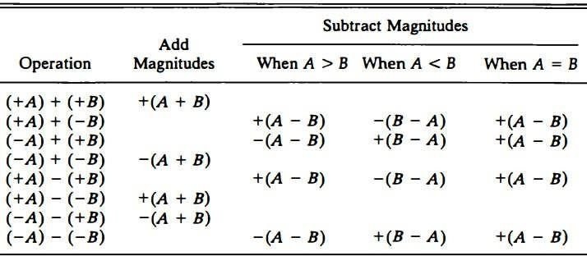

The algorithms for addition and subtraction are derived from the table and can be stated as follows (the words inside parentheses should be used for the subtraction algorithm):

Addition (subtraction) algorithm: when the signs of A and B are identical (different), add the two magnitudes and attach the sign of A to the result. When the signs of A and B are different (identical), compare the magnitudes and subtract the smaller number from the larger. Choose the sign of the result to be the same as A if A > B or the complement of the sign of A if A < B. If the two magnitudes are equal, subtract B from A and make the sign of the result positive. The two algorithms are similar except for the sign comparison. The procedure to be followed for identical signs in the addition algorithm is the same as for different signs in the subtraction algorithm, and vice versa.

Hardware Implementation
To implement the two arithmetic operations with hardware, it is first necessary that the two numbers be stored in registers. Let A and B be two registers that hold the magnitudes of the numbers, and A s and B s be two flip-flops that hold the corresponding signs. The result of the operation may be transferred to a third register: however, a saving is achieved if the result is transferred into A and As. Thus A and As together form an accumulator register. Consider now the hardware implementation of the algorithms above. First, a parallel-adder is needed to perform the micro-operation A + B. Second, a comparator circuit is needed to establish if A > B, A = B, or A < B. Third, two parallel-subtractor circuits are needed to perform the micro- operations A - B and B - A. The sign relationship can be determined from an exclusive-OR gate with A s and B s as inputs. This procedure requires a magnitude comparator, an adder, and two subtractors. However, a different procedure can be found that requires less equipment. First, we know that subtraction can be accomplished by means of complement and add. Second, the result of a comparison can be determined from the end carry after the subtraction. Careful investigation of the alternatives reveals that the use of 2's complement for subtraction and comparison is an efficient procedure that requires only an adder and a complementer. Figure shows a block diagram of the hardware for implementing the addition and subtraction operations.

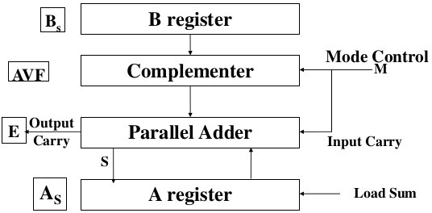
It consists of registers A and B and sign flip-flops As and Bs. Subtraction is done by adding A to the 2's complement of B. The output carry is transferred to flip-flop E, where it can be checked to determine the relative magnitudes of the two numbers. The add-overflow flip-flop AVF holds the overflow bit when A and B are added. The A register provides other micro-operations that may be needed when we specify the sequence of steps in the algorithm.

The addition of A plus B is done through the parallel adder. The S(sum) output of the adder is applied to the input of the A register. The complementer provides an output of B or the complement of B depending on the state of the mode control M. The complementer consists of exclusive-OR gates and the parallel adder consists of full-adder circuits. The M signal is also applied to the input carry of the adder. When M = 0, the output of B is transferred to the adder, the input carry is 0, and the output of the adder is equal to the sum A+B. When M = 1, the 2’s complement of B is applied to the adder the input carry is 1, and output S = A + B’ + 1. This is equal to A plus the 2's complement of B, which is equivalent to the subtraction A -B.

Hardware Algorithm
The flowchart for the hardware algorithm is presented in Figure. The two signs As, and Bs are compared by an exclusive-OR gale. If the output of the gate is 0, the signs are identical; if it is 1, the signs are different for an add operation, identical signs dictate that the magnitudes be added.
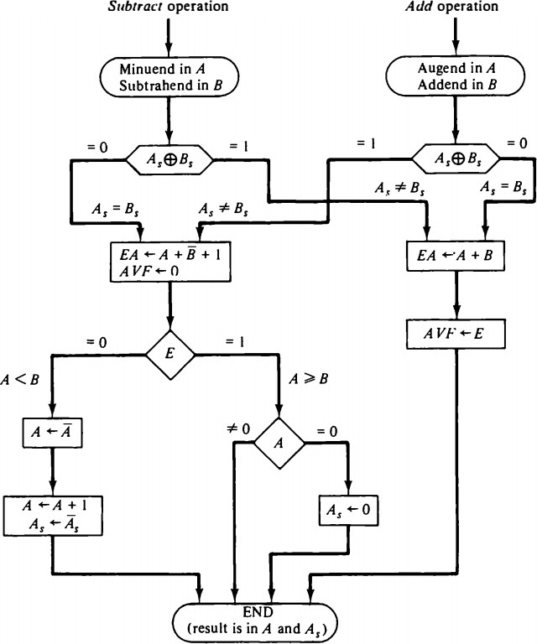

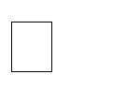
For a subtract operation, different signs dictate that the magnitudes be added. The magnitudes are added with a micro-operation EA <-A + B where EA is a register that combines E and A. The carry in E after the addition constitutes an overflow if it is equal to 1 and it is transferred into the add-overflow flip-flop AVF. The two magnitudes are subtracted if the signs are different for an add operation or identical for a subtract operation. The magnitudes are subtracted by adding A to the 2's complement of B. No overflow can occur if the numbers are subtracted. A 1 in E indicates that A ≥ B and the number in A is the correct result. If this number is zero, the sign As must be made positive to avoid a –0. A 0 in E indicates that A < B. For this case it is necessary to take the 2's complement of the value in A. This operation can be done with one micro-operation A <-A’ + 1. In other paths of the flowchart, the sign of the result is the same as the sign of A, so no change in As is required. However, when A < B, the sign of the result is the complement of the original sign of A. It is then necessary to complement As to obtain the correct sign. The final result is found in register A and its sign in As. The value in AVF provides an overflow indication. The final value of E is immaterial.

Addition and Subtraction with Signed-2’s Complement Data
The signed-2's complement representation of numbers together with arithmetic algorithms for addition and subtraction are summarized here for easy reference. The leftmost bit of a binary number represents the sign bit: 0 for positive and 1 for negative. If the sign bit is 1, the entire number is represented in 2's complement form. Thus +33 is represented as 00100001 and -33 as 11011111. Note that 11011111 is the 2's complement of 00100001, and vice versa.

The addition of two numbers in signed-2's complement form consists of adding the numbers with the sign bits treated the same as the other bits of the number. A carry-out of the sign-bit position is discarded. The subtraction consists of first taking the 2's complement of the subtrahend and then adding it to the minuend. When two numbers of n digits each are added and the sum occupies n + 1 digits, we say that an overflow occurred. An overflow can be detected by inspecting the last two carries out of the addition. When the two carries are applied to an exclusive-OR gate, the overflow is detected when the output of the gate is equal to 1. The register configuration for the hardware implementation is shown in Figure. The sign bits are not separated from the rest of the registers. We name the A register AC and the B register BR. The leftmost bit in AC and BR represent the sign bits of the numbers. The two sign bits are added or subtracted together with the other bits in the complementer and parallel adder. The overflow flip-flop V is set to 1 if there is an overflow. The output carry in this case is discarded.
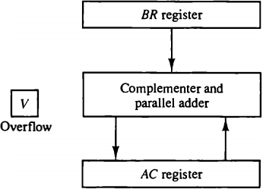
The algorithm for adding and subtracting two binary numbers in signed-2's complement representation is shown in the flowchart of Figure. The sum is obtained by adding the contents of AC and BR (including their sign bits). The overflow bit V is set to 1 if the exclusive-OR of the last two carries is 1, and it is cleared to 0 otherwise. The subtraction operation is accomplished by adding the content of AC to the 2's complement of BR. Taking the 2's complement of BR has the effect of changing a positive number to negative, and vice versa. An overflow must be checked during this operation because the two numbers added could have the same sign. The programmer must realize that if an overflow occurs, there will be an erroneous result in the AC register.
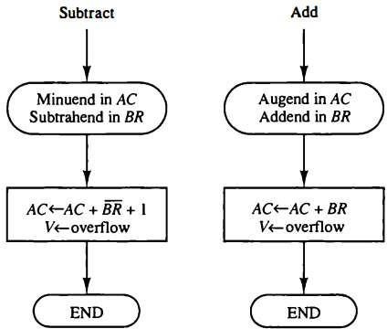

Comparing this algorithm with its signed-magnitude counterpart, we note that it is much simpler to add and subtract numbers if negative numbers are maintained in signed-2's complement representation. For this reason most computers adopt this representation over the more familiar signed-magnitude.

Multiplication Algorithm
Multiplication of two fixed-point binary numbers in signed-magnitude representation is done with paper and pencil by a process of successive shift and add operations. This process is best illustrated with a numerical example.
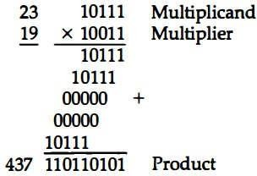
The process consists of looking at successive bits of the multiplier, least significant bit first. If the multiplier bit is a 1, the multiplicand is copied down; otherwise, zeros are copied down. The numbers copied down in successive lines are shifted one position to the left from the previous number. Finally, the numbers are added and their sum forms the product. The sign of the product is determined from the signs of the multiplicand and multiplier. If they are alike, the sign of the product is positive. If they are unlike, the sign of the product is negative.

Hardware Implementation for Signed-MagnitudeData
When multiplication is implemented in a digital computer, it is convenient to change the process slightly. First, instead of providing registers to store and add simultaneously as many binary numbers as there are bits in the multiplier, it is convenient to provide an adder for the summation of only two binary numbers and successively accumulate the partial products in a register. Second, instead of shifting the multiplicand to the left, the partial product is shifted to the right, which results in leaving the partial product and the multiplicand in the required relative positions. Third, when the corresponding bit of the multiplier is 0, there is no need to add all zeros to the partial product since it will not alter its value. The hardware for multiplication consists of the equipment shown in Figure. The multiplier is stored in the Q register and its sign in Qs. The sequence counter SC is initially set to a number equal to the number of bits in the multiplier. The counter is decremented by 1 after forming each partial product. When the content of the counter reaches zero, the product is formed and the process stops.
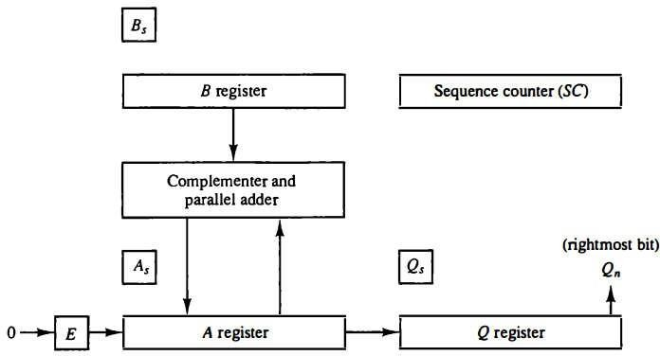
Initially, the multiplicand is in register B and the multiplier in Q. The sum of A and B forms a partial product which is transferred to the EA register. Both partial product and multiplier are shifted to the right. This shift will be denoted by the statement shr EAQ to designate the right shift depicted in Figure. The least significant bit of A is shifted into the most significant position of Q, the bit from E is shifted into the most significant position of A, and 0 is shifted into E. After the shift, one bit of the partial product is shifted into Q, pushing the multiplier bits one position to the right. In this manner, the rightmost flip-flop in register Q, designated by Q„, will hold the bit of the multiplier, which must be inspected next.

Hardware Algorithm
Figure shows a flowchart of the hardware multiply algorithm. Initially, the multiplicand is in B and the multiplier in Q. Their corresponding signs are in Bs and Qs, respectively. The signs are compared, and both A and Q are set to correspond to the sign of the product since a double- length product will be stored in registers A and Q. Registers A and E are cleared and the sequence counter SC is set to a number equal to the number of bits of the multiplier. We are assuming here that operands are transferred to registers from a memory unit that has words of n bits. Since an operand must be stored with its sign, one bit of the word will be occupied by the sign and the magnitude will consist of n — 1 bits.
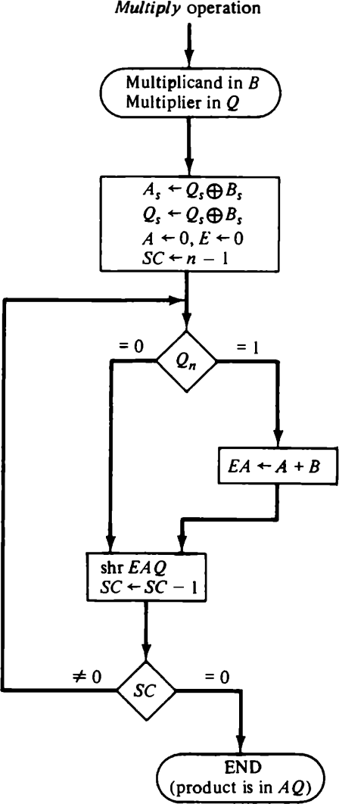

After the initialization, the low-order bit of the multiplier in Qn is tested. If it is a 1, the multiplicand in B is added to the present partial product in A. If it is a 0, nothing is done. Register EAQ is then shifted once to the right to form the new partial product. The sequence
counter is decremented by 1 and its new value checked. If it is not equal to zero, the process is repeated and a new partial product is formed. The process stops when SC = 0. Note that the partial product formed in A is shifted into Q one bit at a time and eventually replaces the multiplier. The final product is available in both A and Q, with A holding the most significant bits and Q holding the least significant bits. The previous numerical example is repeated in Table is shown to clarify the hardware multiplication process. The procedure follows the steps outlined in the flowchart.
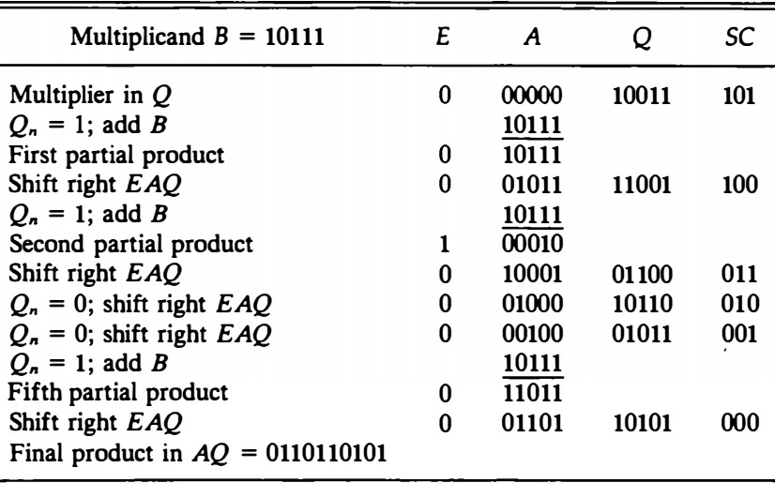

Division Algorithms
Division of two fixed-point binary numbers in signed-magnitude representation is done with paper and pencil by a process of successive compare, shift, and subtract operations. Binary division is simpler than decimal division because the quotient digits are either 0 or 1 and there is no need to estimate how many times the dividend or partial remainder fits into the divisor. The division process is illustrated by a numerical example in Figure. The divisor B consists of five bits and the dividend A, of ten bits. The five most significant bits of the dividend are compared with the divisor. Since the 5-bit number is smaller than B, we try again by taking the six most significant bits of A and compare this number with
B. The 6-bit number is greater than B, so we place a 1 for the quotient bit in the sixth position above the dividend. The divisor is then shifted once to the right and subtracted from the dividend. The difference is called a partial remainder because the division could have stopped here to obtain a quotient of 1 and a remainder equal to the partial remainder. The process is continued by comparing a partial remainder with the divisor. If the partial remainder is greater than or equal to the divisor, the quotient bit is equal to 1. The divisor is then shifted right and subtracted from the partial remainder. If the partial remainder is smaller than the divisor, the quotient bit is 0 and no subtraction is needed. The divisor is shifted once to the right in any case. Note that the result gives both a quotient and a remainder.
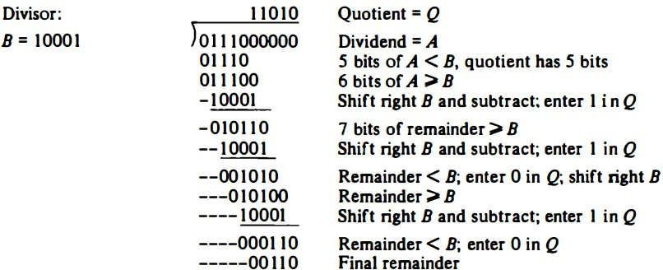

Hardware Implementation for Signed-MagnitudeData
When the division is implemented in a digital computer, it is convenient to change the process slightly. Instead of shifting the divisor to the right, the dividend, or partial remainder, is shifted to the left, thus leaving the two numbers in the required relative position. Subtraction may be achieved by adding A to the 2's complement of B. The information about the relative magnitudes is then available from the end-carry. The hardware for implementing the division operation is identical to that required for multiplication and consists of the components shown in Figure. Register EAQ is now shifted to the left with 0 inserted into Qn and the previous value of E lost. The numerical example is repeated in Figure to clarify the proposed division process. The divisor is stored in the B register and the double-length dividend is stored in registers A and Q. The dividend is shifted to the left and the divisor is subtracted by adding its 2's complement value. The information about the relative magnitude is available in E. If E = 1, it signifies that A is greater than or equal to B.

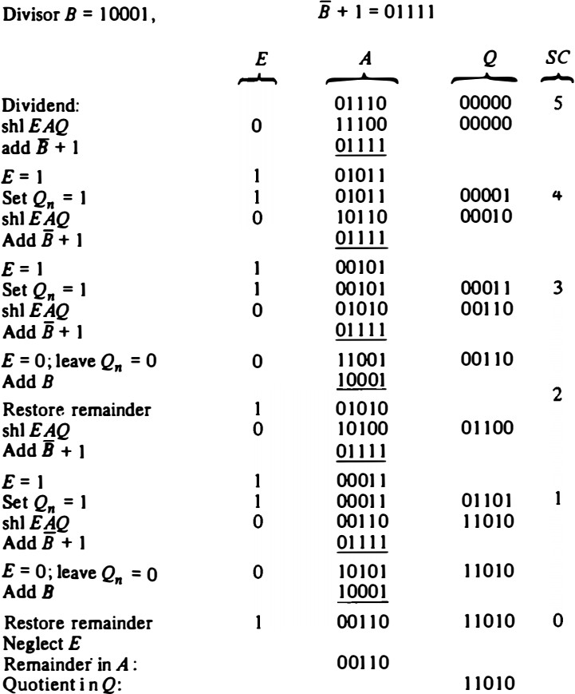

A quotient bit 1 is inserted into Qn and the partial remainder is shifted to the left to repeat the process. If E = 0, it signifies that A < B so the quotient in Qn remains a 0 (inserted during the shift). The value of B is then added to restore the partial remainder in A to its previous value. The partial remainder is shifted to the left and the process is repeated again until all five quotient bits are formed. Note that while the partial remainder is shifted left, the quotient bits are shifted also and after five shifts, the quotient is in Q and the final remainder is in A.

Before showing the algorithm in flowchart form, we have to consider the sign of the result and a possible overflow condition. The sign of the quotient is determined from the signs of the dividend and the divisor. If the two signs are alike, the sign of the quotient is plus. If they are unalike, the sign is minus. The sign of the remainder is the same as the sign of the dividend.

Divide Overflow
The division operation may result in a quotient with an overflow. This is not a problem when working with paper and pencil but is critical when the operation is implemented with hardware. This is because the length of registers is finite and will not hold a number that exceeds the standard length. To see this, consider a system that has 5-bit registers. We use one register to hold the divisor and two registers to hold the dividend. From the example of Figure we note that the quotient will consist of six bits if the five most significant bits of the dividend constitute a number greater than the divisor. The quotient is to be stored in a standard 5-bit register, so the overflow bit will require one more flip-flop for storing the sixth bit. This divide- overflow condition must be avoided in normal computer operations because the entire quotient will be too long for transfer into a memory unit that has words of standard length, that is, the same as the length of registers. Provisions to ensure that this condition is detected must be included in either the hardware or the software of the computer, or in a combination of the two.

When the dividend is twice as long as the divisor, the condition for overflow can be stated as follows: A divide-overflow condition occurs if the high-order half bits of the dividend constitute a number greater than or equal to the divisor. Another problem associated with division is the fact that a division by zero must be avoided. The divide-overflow condition takes care of this condition as well. This occurs because any dividend will be greater than or equal to a divisor which is equal to zero. Overflow condition is usually detected when a special flip-flop is set. We will call it a divide-overflow flip-flop and label it DVF.

Hardware Algorithm
The hardware divide algorithm is shown in the flowchart of Figure. The dividend is in A and Q and the divisor in B. The sign of the result is transferred into Qs to be part of the quotient. A constant is set into the sequence counter SC to specify the number of bits in the quotient. As in multiplication, we assume that operands are transferred to registers from a memory unit that has words of n bits. Since an operand must be stored with its sign, one bit of the word will be occupied by the sign and the magnitude will consist of n - 1 bits.

A divide-overflow condition is tested by subtracting the divisor in B from half of the bits of the dividend stored in A. If A is greater than or equal to B, the divide-overflow flip-flop DVF is set and the operation is terminated prematurely. If A < B, no divide overflow occurs so the value of the dividend is restored by adding B to A. The division of the magnitudes starts by shifting the dividend in AQ to the left with the high-order bit shifted into E. If the bit shifted into E is 1, we know that EA > B because EA consists of a 1 followed by n-l bits while B consists of only n-1 bits. In this case, B must be subtracted from EA and 1 inserted into Qn for the quotient bit. Since register A is missing the high-order bit of the dividend (which is in E), its value is EA – 2n-1. Adding to this value the 2's complement of B results in (EA – 2n-1) + (2n-1 - B) = EA - B The carry from this addition is not transferred to E if we want E to remain a 1.

If the shift-left operation inserts a 0 into E, the divisor is subtracted by adding its 2's complement value and the carry is transferred into E. If E = 1, it signifies that A greater than or equal to B; therefore, Qn is set to 1. If E = 0, it signifies that A < B and the original number is restored by adding B to A. In the latter case we leave a 0 in Qn (0 was inserted during the shift).

This process is repeated again with register A holding the partial remainder. After n-l times, the quotient magnitude is formed in register Q and the remainder is found in register A. The quotient sign is in Qs and the sign of the remainder in As is the same as the original sign of the dividend.
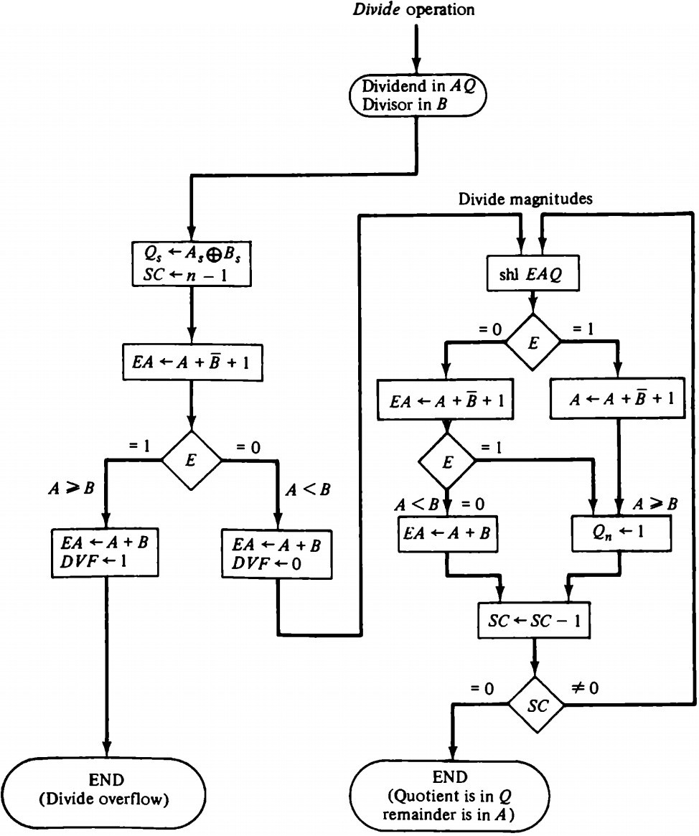

Floating-Point Arithmetic Operations
Many high-level programming languages have a facility for specifying floating-point numbers. Any computer that has a compiler for such high-level programming language must have a provision for handling floating-point arithmetic operations. The operations are quite often included in the internal hardware. If no hardware is available for the operations, the compiler must be designed with a package of floating-point software subroutines. Although the hardware method is more expensive, it is so much more efficient than the software method that floating-point hardware is included in4nost computers and is omitted only in very small ones.

A floating-point number in computer registers consists of two parts: a mantissa m and an exponent e. The two parts represent a number obtained from multiplying m times a radix r raised to the value of e ; thus m x re. The mantissa may be a fraction or an integer. The location of the radix point and the value of the radix r are assumed and are not included in the registers. For example, assume a fraction representation and a radix 10. The decimal number 537.25 is represented in a register with m = 53725 and e = 3 and is interpreted to represent the floating- point number 0.53725 x 10^3. A floating-point number is normalized if the most significant digit of the mantissa is nonzero. In this way the mantissa contains the maximum possible number of significant digits. A zero cannot be normalized because it does not have a nonzero digit. It is represented in floating-point by all 0's in the mantissa and exponent.

Arithmetic operations with floating-point numbers are more complicated than with fixed-point numbers and their execution takes longer and requires more complex hardware. Adding or subtracting two numbers requires first an alignment of the radix point since the exponent parts must be made equal before adding or subtracting the mantissas. The alignment is done by shifting one mantissa while its exponent is adjusted until it is equal to the other exponent. Consider the sum of the following floating-point numbers:
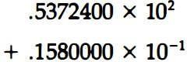
It is necessary that the two exponents be equal before the mantissas can be added. We can either shift the first number three positions to the left, or shift the second number three positions to the right. When the mantissas are stored in registers, shifting to the left causes a loss of most significant digits. Shifting to the right causes a loss of least significant digits. The second method is preferable because it only reduces the accuracy, while the first method may cause an error. The usual alignment procedure is to shift the mantissa that has the smaller exponent to the right by a number of places equal to the difference between the exponents. After this is done, the mantissas can be added:

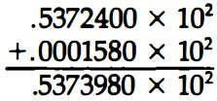
When two normalized mantissas are added, the sum may contain an overflow digit. An overflow can be corrected easily by shifting the sum once to the right and incrementing the exponent. When two numbers are subtracted, the result may contain most significant zeros as shown in the following example:
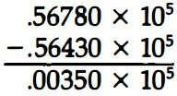
A floating-point number that has a 0 in the most significant position of the mantissa is said to have an underflow. To normalize a number that contains an underflow, it is necessary to shift the mantissa to the left and decrement the exponent until a nonzero digit appears in the first position. In the example above, it is necessary to shift left twice to obtain .35000 x 10 3 . In most computers, a normalization procedure is performed after each operation to ensure that all results are in a normalized form.

Floating-point multiplication and division do not require an alignment of the mantissas. The product can be formed by multiplying the two mantissas and adding the exponents. Division is accomplished by dividing the mantissas and subtracting the exponents. The operations performed with the mantissas are the same as in fixed-point numbers, so the two can share the same registers and circuits. The operations performed with the exponents are compare and increment (for aligning the mantissas), add and subtract (for multiplication and division), and decrement (to normalize the result). The exponent may be represented in any one of the three representations: signed-magnitude, signed-2 , s complement, or signed-l's complement.

A fourth representation employed in many computers is known as a biased exponent. In this representation, the sign bit is removed from being a separate entity. The bias is a positive number that is added to each exponent as the floating-point number is formed, so that internally all exponents are positive. The following example may clarify this type of representation. Consider an exponent that ranges from -50 to 49. Internally, it is represented by two digits (without a sign) by adding to it a bias of 50. The exponent register contains the number e + 50, where e is the actual exponent. This way, the exponents are represented in registers as positive numbers in the range of 00 to 99. Positive exponents in registers have the range of numbers from 99 to 50. The subtraction of 50 gives the positive values from 49 to 0. Negative exponents are represented in registers in the range from 49 to 00. The subtraction of 50 gives the negative values in the range of -1 to -50. The advantage of biased exponents is that they contain only positive numbers. It is then simpler to compare their relative magnitude without being concerned with their signs. As a consequence, a magnitude comparator can be used to compare their relative magnitude during the alignment of the mantissa. Another advantage is that the smallest possible biased exponent contains all zeros. The floating-point representation of zero is then a zero mantissa and the smallest possible exponent.

Register Configuration
The register configuration for floating-point operations is quite similar to the layout for fixed- point operations. As a general rule, the same registers and adder used for fixed-point arithmetic are used for processing the mantissas. The difference lies in the way the exponents are handled. The register organization for floating-point operations is shown in Figure. There are three registers, BR, AC, and QR. Each register is subdivided into two parts. The mantissa part has the same uppercase letter symbols as in fixed-point representation. The exponent part uses the corresponding lower-case letter symbol. It is assumed that each floating-point number has a mantissa in signed-magnitude representation and a biased exponent. Thus the AC has a mantissa whose sign is in A s and a magnitude that is in A. The exponent is in the part of the register denoted by the lowercase letter symbol a. The diagram shows explicitly the most significant bit of A, labeled by A1. The bit in this position must be a 1 for the number to be normalized. Note that the symbol AC represents the entire register, that is, the concatenation of As, A1, and a. Similarly, register BR is subdivided into Bs, B, and b, and QR into Qs, Q, and q.
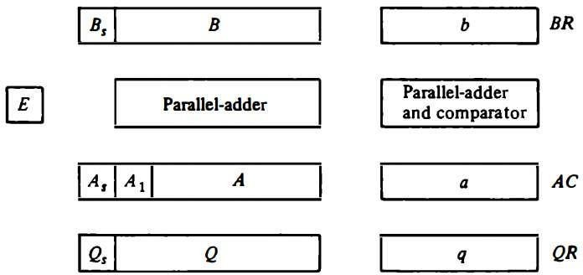

A parallel-adder adds the two mantissas and transfers the sum into A and the carry into E. A separate parallel-adder is used for the exponents. Since the exponents are biased, they do not have a distinct sign bit but are represented as a biased positive quantity. It is assumed that the floating-point numbers are so large that the chance of an exponent overflow is very remote, and for this reason the exponent overflow will be neglected. The exponents are also connected to a magnitude comparator that provides three binary outputs to indicate their relative magnitude. The number in the mantissa will be taken as a fraction, so the binary point is assumed to reside to the left of the magnitude part. Integer representation for floating-point causes certain scaling problems during multiplication and division. To avoid these problems, we adopt a fraction representation. The numbers in the registers are assumed to be initially normalized. After each arithmetic operation, the result will be normalized. Thus all floating-point operands coming from and going to the memory unit are always normalized.

Addition and Subtraction
During addition or subtraction, the two floating-point operands are in AC and BR. The sum or difference is formed in the AC. The algorithm can be divided into four consecutive parts:
- Check for zeros.
- Align the mantissas.
- Add or subtract the mantissas.
- Normalize the result.

A floating-point number that is zero cannot be normalized. If this number is used during the computation, the result may also be zero. Instead of checking for zeros during the normalization process we check for zeros at the beginning and terminate the process if necessary. The alignment of the mantissas must be carried out prior to their operation. After the mantissas are added or subtracted, the result may be unnormalized. The normalization procedure ensures that the result is normalized prior to its transfer to memory.

The flowchart for adding or subtracting two floating-point binary numbers is shown in Figure. If BR is equal to zero, the operation is terminated, with the value in the AC being the result. If AC is equal to zero, we transfer the content of BR into AC and also complement its sign if the numbers are to be subtracted. If neither number is equal to zero, we proceed to align the mantissas.

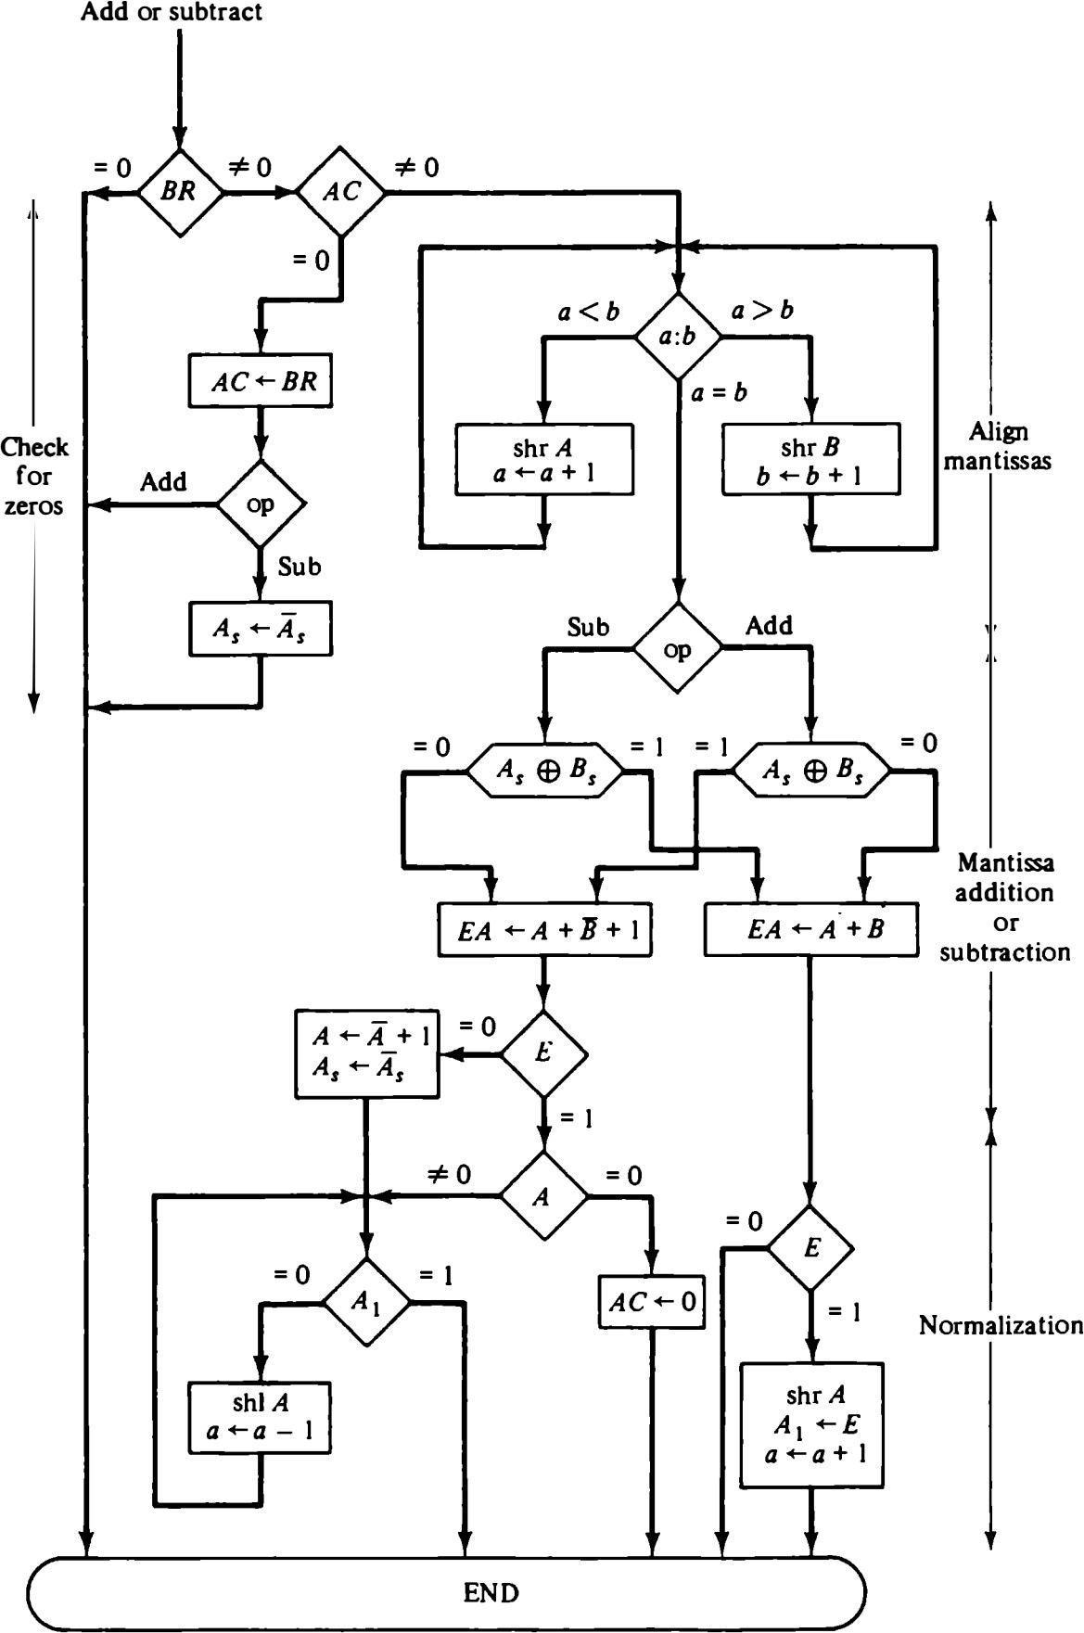
The magnitude comparator attached to exponents a and b provides three outputs that indicate their relative magnitude. If the two exponents are equal, we go to perform the arithmetic operation. If the exponents are not equal, the mantissa having the smaller exponent is shifted to the right and its exponent incremented. This process is repeated until the two exponents are equal.

The addition and subtraction of the two mantissas is identical to the fixed-point addition and subtraction algorithm. The magnitude part is added or subtracted depending on the operation and the signs of the two mantissas. If an overflow occurs when the magnitudes are added, it is transferred into flip-flop E. If E is equal to 1, the bit is transferred into A1 and all other bits of A are shifted right. The exponent must be incremented to maintain the correct number. No underflow may occur in this case because the original mantissa that was not shifted during the alignment was already in a normalized position. If the magnitudes were subtracted, the result may be zero or may have an underflow. If the mantissa is zero, the entire floating-point number in the AC is made zero. Otherwise, the mantissa must have at least one bit that is equal to 1. The mantissa has an underflow if the most significant bit in position A1 is 0. In that case, the mantissa is shifted left and the exponent decremented. The bit in A1 is checked again and the process is repeated until it is equal to 1. When A1 = 1, the mantissa is normalized and the operation is completed.

Multiplication
The multiplication of two floating-point numbers requires that we multiply the mantissas and add the exponents. No comparison of exponents or alignment of mantissas is necessary. The multiplication of the mantissas is performed in the same way as in fixed-point to provide a double-precision product. The double- precision answer is used in fixed-point numbers to increase the accuracy of the product. In floating-point, the range of a single-precision mantissa combined with the exponent is usually accurate enough so that only single-precision numbers are maintained. Thus the half most significant bits of the mantissa product and the exponent will be taken together to form a single-precision floating-point product.

The multiplication algorithm can be subdivided into four parts:
- Check for zeros.
- Add the exponents.
- Multiply the mantissas.
- Normalize the product.

Steps 2 and 3 can be done simultaneously if separate adders are available for the mantissas and exponents. The flowchart for floating-point multiplication is shown in Figure. The two operands are checked to determine if they contain a zero. If either operand is equal to zero, the product in the AC is set to zero and the operation is terminated. If neither of the operands is equal to zero, the process continues with the exponent addition. The exponent of the multiplier is in q and the adder is between exponents a and b. It is necessary to transfer the exponents from q to a, add the two exponents, and transfer the sum into a. Since both exponents are biased by the addition of a constant, the exponent sum will have double this bias. The correct biased exponent for the product is obtained by subtracting the bias number from the sum. The multiplication of the mantissas is done as in the fixed-point case with the product residing in A and Q. Overflow cannot occur during multiplication, so there is no need to check for it.

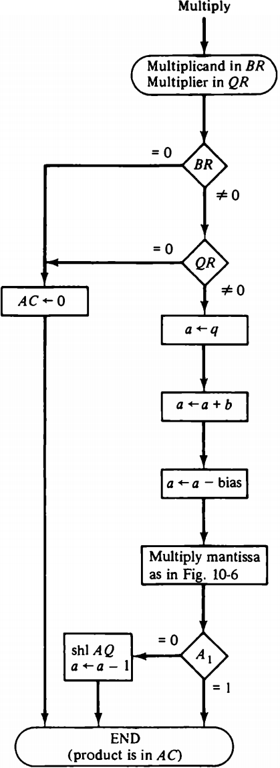
The product may have an underflow, so the most significant bit in A is checked. If it is a 1, the product is already normalized. If it is a 0, the mantissa in AQ is shifted left and the exponent decremented. Note that only one normalization shift is necessary. The multiplier and multiplicand were originally normalized and contained fractions. The smallest normalized operand is 0.1, so the smallest possible product is 0.01. Therefore, only one leading zero may occur. Although the low-order half of the mantissa is in Q, we do not use it for the floating- point product. Only the value in the AC is taken as the product.

Division
Floating-point division requires that the exponents be subtracted and the mantissas divided. The mantissa division is done as in fixed-point except that the dividend has a single-precision mantissa that is placed in the AC. Remember that the mantissa dividend is a fraction and not an integer. For integer representation, a single-precision dividend must be placed in register Q and register A must be cleared. The zeros in A are to the left of the binary point and have no significance. In fraction representation, a single-precision dividend is placed in register A and register Q is cleared. The zeros in Q are to the right of the binary point and have no significance. The check for divide-overflow is the same as in fixed-point representation. However, with floating-point numbers the divide-overflow imposes no problems. If the dividend is greater than or equal to the divisor, the dividend fraction is shifted to the right and its exponent incremented by 1. For normalized operands this is a sufficient operation to ensure that no mantissa divide-overflow will occur. The operation above is referred to as a dividend alignment. The division of two normalized floating-point numbers will always result in a normalized quotient provided that a dividend alignment is carried out before the division. Therefore, unlike the other operations, the quotient obtained after the division does not require a normalization.

The division algorithm can be subdivided into five parts:
1.
1. Check for zeros.
- Initialize registers and evaluate the sign.
- Align the dividend.
- Subtract the exponents.
- Divide the mantissas.

The flowchart for floating-point division is shown in Figure. The two operands are checked for zero. If the divisor is zero, it indicates an attempt to divide by zero, which is an illegal operation. The operation is terminated with an error message. An alternative procedure would be to set the quotient in QR to the most positive number possible (if the dividend is positive) or to the most negative possible (if the dividend is negative). If the dividend in AC is zero, the quotient in QR is made zero and the operation terminates.

If the operands are not zero, we proceed to determine the sign of the quotient and store it in Qs. The sign of the dividend in As is left unchanged to be the sign of the remainder. The Q register is cleared and the sequence counter SC is set to a number equal to the number of bits in the quotient. The dividend alignment is similar to the divide-overflow check in the fixed-point operation. The proper alignment requires that the fraction dividend be smaller than the divisor. The two fractions are compared by a subtraction test. The carry in E determines their relative magnitude. The dividend fraction is restored to its original value by adding the divisor. If A is greater than or equal to B, it is necessary to shift A once to the right and increment the dividend exponent. Since both operands are normalized, this alignment ensures that A < B. Next, the divisor exponent is subtracted from the dividend exponent. Since both exponents were originally biased, the subtraction operation gives the difference without the bias. The bias is then added and the result transferred into q because the quotient is formed in QR. The magnitudes of the mantissas are divided as in the fixed-point case. After the operation, the mantissa quotient resides in Q and the remainder in A. The floating-point quotient is already normalized and resides in QR.
The exponent of the remainder should be the same as the exponent of the dividend. The binary point for the remainder mantissa lies (n—1) positions to the left of A1. The remainder can be converted to a normalized fraction by subtracting n - 1 from the dividend exponent and by shift and decrement until the bit in A1 is equal to 1. This is not shown in the flow chart.
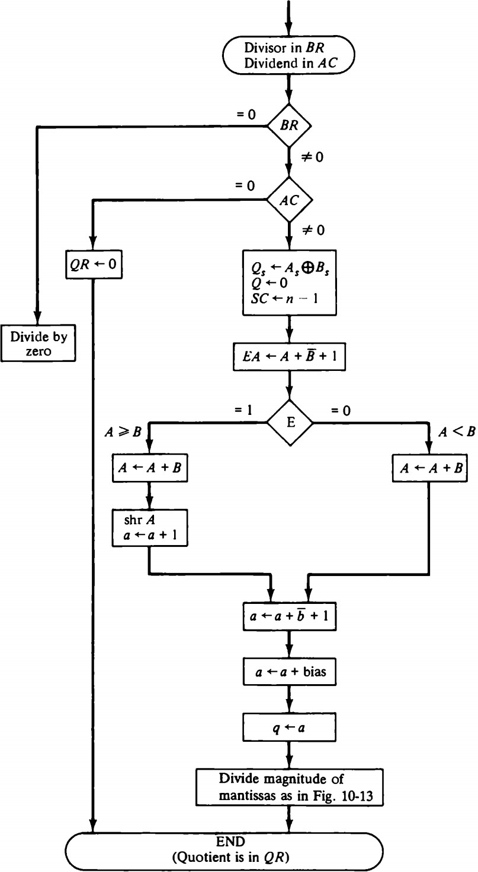

Memory locations and addresses

Number and character operands, as well as instructions, are stored in the memory of a computer. The memory consists of many millions of storage cells, each of which can store a bit of information having the value 0 or 1. Because a single bit represents a very small amount of information, bits are seldom handled individually. The usual approach is to deal with them in groups of fixed size. For this purpose, the memory is organized so that a group of n bits can be stored or retrieved in a single, basic operation. Each group of n bits is referred to as a word of information, and n is called the word length. The memory of a computer can be schematically represented as a collection of words as shown in figure (a).

Modern computers have word lengths that typically range from 16 to 64 bits. If the word length of a computer is 32 bits, a single word can store a 32-bit 2’s complement number or four ASCII characters, each occupying 8 bits. A unit of 8 bits is called a byte.

Accessing the memory to store or retrieve a single item of information, either a word or a byte, requires distinct names or addresses for each item location. It is customary to use numbers from 0 through 2^{K}-1, for some suitable values of k, as the addresses of successive locations in the memory. The 2^{k} addresses constitute the address space of the computer, and the memory can have up to 2^{k} addressable locations. 24-bit address generates an address space of 2²⁴ (16,777,216) locations. A 32-bit address creates an address space of 2³² or 4G (4 giga) locations.

BYTE ADDRESSABILITY:-
We now have three basic information quantities to deal with: the bit, byte and word. A byte is always 8 bits, but the word length typically ranges from 16 to 64 bits. The most practical assignment is to have successive addresses refer to successive byte

Fig a Memory words

n bits

…
…
…

…
…
…
Last word
i-th word
Second word
First word

- A signed integer

32 bits
b31 | b30 | ……. | b1 | b0

Sign bit: b31 = 0 for positive numbers b32 = 1 for negative numbers

- Four characters

8 bits | 8 bits | 8 bits | 8 bits
ASCII | ASCII | ASCII | ASCII
Character | Character | character | character

Locations in the memory. This is the assignment used in most modern computers, and is the one we will normally use in this book. The term byte-addressable memory is use for this assignment. Byte locations have addresses 0,1,2, …. Thus, if the word length of the machine is 32 bits, successive words are located at addresses 0,4,8,…., with each word consisting of four bytes.

BIG-ENDIAN AND LITTLE-ENDIAN ASIGNMENTS:-
There are two ways that byte addresses can be assigned across words, as shown in fig b. The name big-endian is used when lower byte addresses are used for the more significant bytes (the leftmost bytes) of the word. The name little-endian is used for the opposite ordering, where the lower byte addresses are used for the less significant bytes (the rightmost bytes) of the word.
In addition to specifying the address ordering of bytes within a word, it is also necessary to specify the labeling of bits within a byte or a word. The same ordering is also used for labeling bits within a byte, that is, b7, b6, …., b0, from left to right.
Word
0 | 1 | 2 | 3
4 | 5 | 6 | 7
 | ….
 | ….
 | ….
2^{k}-4 | 2^{k}-3 | 2^{k}-2 | 2^{k}-1

0

4

2^{k}-4

0

4
3 | 2 | 1 | 0
7 | 6 | 5 | 4
 | ….
 | ….
 | ….
2^{k}-1 | 2^{k}-2 | 2^{k}-3 | 2^{k}-4

2^{k}-4

WORD ALIGNMENT:-
In the case of a 32-bit word length, natural word boundaries occur at addresses 0, 4, 8, …, as shown in above fig. We say that the word locations have aligned addresses . in general, words are said to be aligned in memory if they begin at a byte address that is a multiple of the number of bytes in a word. The memory of bytes in a word is a power of
2. Hence, if the word length is 16 (2 bytes), aligned words begin at byte addresses 0,2,4,…, and for a word length of 64 (23 bytes), aligned words begin at bytes addresses 0,8,16 ….

There is no fundamental reason why words cannot begin at an arbitrary byte address. In that case, words are said to have unaligned addresses. While the most common case is to use aligned addresses, some computers allow the use of unaligned word addresses.

ACCESSING NUMBERS, CHARACTERS, AND CHARACTER STRINGS:-
A number usually occupies one word. It can be accessed in the memory by specifying its word address. Similarly, individual characters can be accessed by their byte address.

In many applications, it is necessary to handle character strings of variable length. The beginning of the string is indicated by giving the address of the byte containing its first character. Successive byte locations contain successive characters of the string. There are two ways to indicate the length of the string. A special control character with the meaning “end of string” can be used as the last character in the string, or a separate memory word location or processor register can contain a number indicating the length of the string in bytes.

Memory operations
Both program instructions and data operands are stored in the memory. To execute an instruction, the processor control circuits must cause the word (or words) containing the instruction to be transferred from the memory to the processor. Operands and results must also be moved between the memory and the processor. Thus, two basic operations involving the memory are needed, namely, Load (or Read or Fetch) and Store (or Write).

The load operation transfers a copy of the contents of a specific memory location to the processor. The memory contents remain unchanged. To start a Load operation, the processor sends the address of the desired location to the memory and requests that its

contents be read. The memory reads the data stored at that address and sends them to the processor.

The store operation transfers an item of information from the processor to a specific memory location, destroying the former contents of that location. The processor sends the address of the desired location to the memory, together with the data to be written into that location.

An information item of either one word or one byte can be transferred between the processor and the memory in a single operation. Actually this transfer in between the CPU register & main memory.

ADDRESSING MODES
The addressing mode specifies a rule for interpreting or modifying the address field of the instruction before the operand is actually referenced.
In simple terms, Addressing mode is the way in which the location of an operand can be specified in an instruction. It generates an effective address (the actual address of the operand).

Instruction format with mode field

Types of Addressing Modes:
- Implied Mode
- Immediate Mode
- Register Mode
- Register Indirect Mode:
- Autoincrement or Autodecrement Mode
- Direct Address Mode
- Indirect Address Mode
- Relative Address Mode
- Indexed Addressing Mode
- Base Register Addressing Mode

There are two modes that need no address field at all. These are the implied and immediate modes.
- Implied Mode: In this mode the operands are specified implicitly in the definition of the instruction.
For example, the instruction ”complement accumulator (CMA)” is an implied-mode instruction because the operand in the accumulator register is implied in the definition of the instruction. In fact, all register reference instructions that use an accumulator are implied-mode instructions. Zero-address instructions in a stack-organized computer are implied-mode instructions since the operands are implied to be on top of the stack.

- Immediate Mode: In this mode the operand is specified in the instruction itself. In other words, an immediate-mode instruction has an operand field rather than an address field. The operand field contains the actual operand to be used in conjunction with the operation specified in the instruction.
EX: LDAC #34H
LDAC loads data from memory to accumulator. Therefore, AC=00110100.

When the address field specifies a processor register, the instruction is said to be in the register mode.
- Register Mode: In this mode the operands are in registers that reside within the CPU. The particular register is selected from a register field in the instruction.

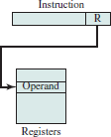
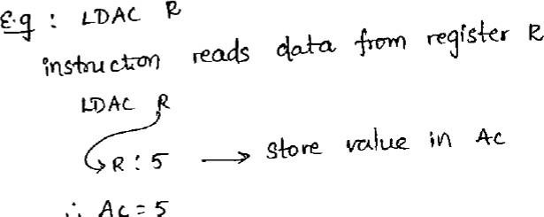
- Register Indirect Mode: In this mode the instruction specifies a register in the CPU whose contents give the address of the operand in memory. In other words, the selected register contains the address of the operand rather than the operand itself.
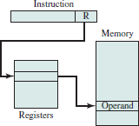
EX: LDAC (R1)
If R1cotains the address of an operand in the memory, for example: address of an operand is 2000 which contains a value 350. Result: 350 is stored in the AC.
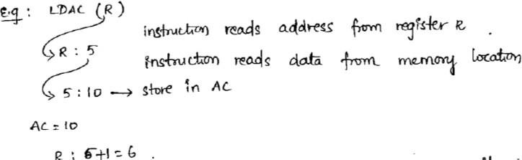
- Autoincrement Mode: This is similar to the register indirect mode except that the register is incremented or decremented after (or before) its value is used to access memory. The effective address of the operand is the contents of a register specified in the instruction. After accessing the operand, the contents of the register are automatically incremented to the next value.
- Autodecrement Mode
The effective address of the operand is the contents of a register specified in the instruction. Before accessing the operand, the contents of this register are automatically decremented and then the value is accessed.
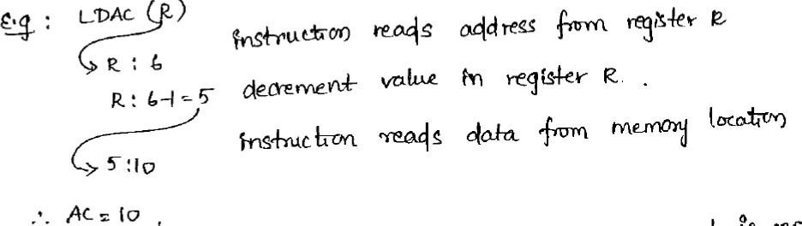
Sometimes the value given in the address field is the address of the operand, but sometimes it is just an address from which the address of the operand is calculated
.
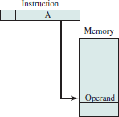
- Direct Address Mode: In this mode the effective address is equal to the address part of the instruction. The operand resides in memory and its address is given directly by the address field of the instruction. In a branch-type instruction the address field specifies the actual branch address.

Ex: LDAC 5000
This instruction reads the operand from the Memory location 5000. if the memory location 5000 contains a value 250, then it will be stored in AC.
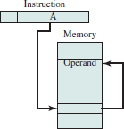
- Indirect Address Mode: In this mode the address field of the instruction gives the address where the effective address is stored in memory. Control fetches the instruction from memory and uses its address part to access memory again to read the effective address.

EX: ADD (A), R1
➔ If A is address of EA. For example: address of A is 1000 which contains 3000, 3000 is an address of an operand (EA).
➔ This instruction reads an operand from the location address 3000 and adds its contents to R1.
A few addressing modes require that the address field of the instruction be added to the content of a specific register in the CPU. The effective address in these modes is obtained from the following computation:

➔ effective address = address part of instruction + content of CPU register
The CPU register used in the computation may be the program counter, an index register, or a base register. In either case we have a different addressing mode which is used for a different application.
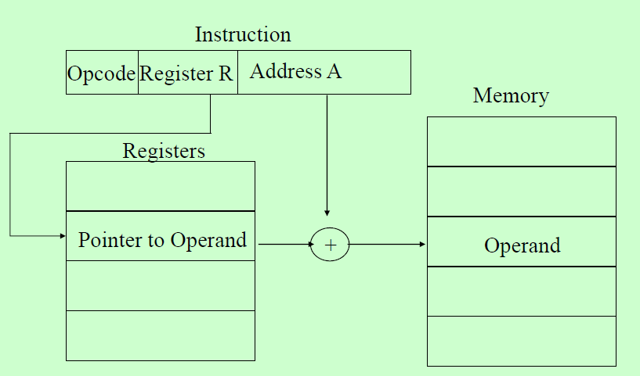
- Relative Address Mode:
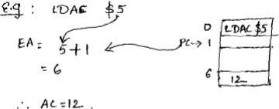
In this mode the content of the program counter is added to the address part of the instruction in order to obtain the effective address.

EX:
PC= address of next instruction , i.e., 1. The address given in the instruction is 5 Then EA= 5 + 1= 6 which contains a value 12. Finally AC contains 12.
- Indexed Addressing Mode:
In this mode the content of an index register is added to the address part of the instruction to obtain the effective address.

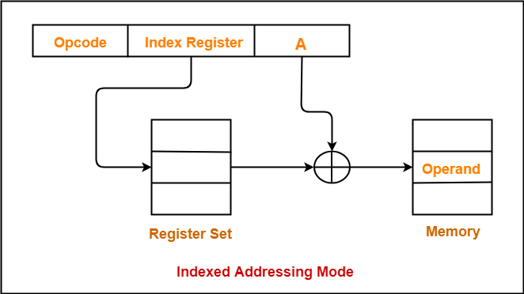

Ex: LDAC A(XR)
Assume XR=100, A=500
This instruction reads the operand from the effective address (600) i.e., EA= XR contents (index register) + 500
= 100 + 500=600
If memory location at 600 contains a value 55 (assume), This 55 will be stored in AC.

- Base Register Addressing Mode:
In this mode the content of a base register is added to the address part of the instruction to obtain the effective address.

Ex: LDAC A(R) Assume R=1000, A=50
This instruction reads the operand from the effective address (1050) i.e., EA= R contents (Base register) + 50

= 1000 + 50=1050
If memory location at 1050 contains a value 255 (assume), this 255 will be stored in AC.
Numerical Example:
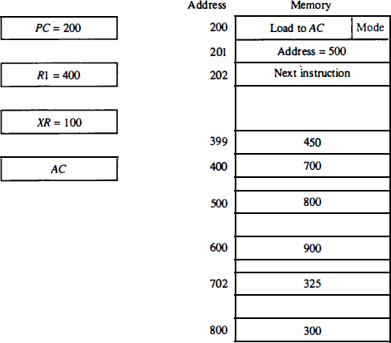

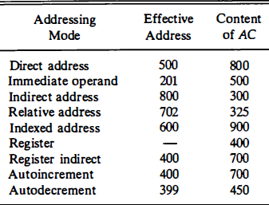

INSTRUCTION FORMAT:

The most common fields found in instruction formats are:
  - An operation code field that specifies the operation to be performed.
  - An address field that designates a memory address or a processor register.
  - A mode field that specifies the way the operand or the effective address is determined.

Most computers fall into one of three types of CPU organizations:
- Single accumulator organization.
- General register organization.
- Stack organization.

An accumulator-type organization:
All operations are performed with an implied accumulator register. The instruction format in this type of computer uses one address field. For example, the instruction that specifies an arithmetic addition is defined by an assembly language instruction as:

ADD X
where X is the address of the operand. The ADD instruction in this case results in the operation AC = AC + M[X]. AC is the accumulator register and M [X] symbolizes the memory word located at address X.

A general register type of organization:
The instruction format in this type of computer needs three register address fields. Thus the instruction for an arithmetic addition may be written in an assembly language as

ADD R1 , R2 , R3
to denote the operation R 1 = R2 + R 3 . The number o f address fields in the instruction can be reduced from three to two if the destination register is the same as one of the source registers. Thus the instruction

ADD R1 , R2
would denote the operation R1 = R1 + R2. Only register addresses for R1 and R2 need be specified in this instruction.

General register-type computers employ two or three address fields in their instruction format. Each address field may specify a processor register or a memory word. An instruction symbolized by

ADD R1 , X
would specify the operation R1 ← R1 + M[X]. It has two address fields, one for register R1 and the other for the memory address X.

A stack organization:
Computers with stack organization would have PUSH and POP instructions which require an address field. Thus the instruction

PUSH X

To illustrate the influence of the number of addresses on computer programs, we will evaluate the arithmetic statement

X = (A + B) • (C + D)

using zero, one, two, or three address instructions. We will use the symbols ADD, SUB, MUL, and DIV for the four arithmetic operations; MOV for the transfer-type operation; and LOAD and STORE for transfers to and from memory and AC register. We will assume that the operands are in memory addresses A, B, C, and D, and the result must be stored in memory at address X.

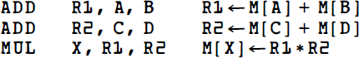
Three-Address Instructions:
Two-Address Instructions:
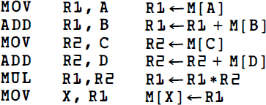

One-Address Instructions:
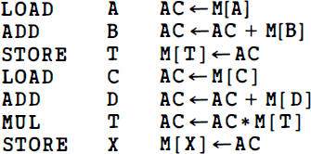
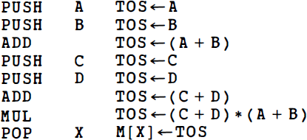
Zero-Address Instructions:
RISC Instructions:
